## Contents

Contents i

List of Figures iv

List of Tables v

Abstract vi

Chapter 1 7

Introduction 7

1.1 Introduction to ML…………...……………………………………….7 1.2 Motivation 7

1.3 Technical Aspects 8

1.4Impact of ML 8

1.5 Summary 8

Chapter 2 9

Literature Review 9

2.1 Literature Survey on the impact of Covid-19 pandemic on Urological emergencies 9

2.2 Literature Survey on developing a COVID-19 mortality risk prediction model when individual-level data are not available. 9

2.3 Literature Survey on COVID-19 Diagnosis, Treatments and Prevention. 10

2.4 Literature Survey on CoronaTracker: World-wide COVID-19 Outbreak Data Analysis and Prediction 10

2.5 Proposed System 11

2.6 Aim,Objectives and Methodology 11

2.7 Summary 12

Chapter 3 13

Design 13

3.1 Design Procedure 13

3.2 System Architecture 13

3.3 UML 14

3.3.1 Use Case diagram 15

3.3.2 Sequence diagram 16

3.3.3 Class diagram 17

3.3 Activity diagram 18

3.4 Summary 19

Chapter 4 20

Implementation 20

4.1 Importing the dataset and Encoding 20

4.2 Training and Testing the model using various algorithms 21

4.3 Connecting the model to the Front End 24

Chapter 5 26

**Testing …………………………………………….……………………….**26

5.1Introduction of Testing 26

5.2 Software Testing. 26

5.2 .1 Unit Testing. 26

5.2.2 User Acceptance Testing. 28

5.2.3 Output Testing. 28

5.2.4 Validation Checking. 28

5.3 System Testing 29

Chapter 6 30

Results and Discussions 30

Chapter 7 34

Conclusion and Future Work 34

7.1 Conclusion 34

7.2 Future Work 34

References 35

## 

## List of Figures

Figure 3.1 System Architecture 14

Figure 3.2 use case diagram for users 15

Figure 3.3 sequence diagram 16

Figure 3.4 class diagram 17

Figure 3.5 Activity diagram 18

Figure 6.1 Home page 30

Figure 6.2 Symptoms 30

Figure 6.3 Precautions. 31

Figure 6.4 Treatments 31

Figure 6.5 Treatments 32

Figure 6.6 Treatments 32

Figure 6.7 Covid-19 Risk Level 33

Figure 6.8 Result 33

List of Tables

Table 5‑1: Test cases for the project 27

Table 5‑2: Test cases for Input-Output 29

## Abstract

There is a new world health crisis threatening the public with spread of COVID-19 (Coronavirus Disease-2019). Since December 2019, when Covid-19 emerged in Hunan seafood market at Wuhan, South China and rapidly spread throughout the world, the virus outbreak has been declared a public health emergency of International concern by World Health Organization (WHO). We here summarize the current clinical characteristics data to guide potential COVID-19 about Prevention, Diagnosis, Treatments and Prevention of COVID-19. In this review, we extracted data from various Research Report, WHO guidelines and other articles. It is important to caution the readers that new data updating nearly every hour regarding clinical characteristics, diagnosis, treatment strategies, and outcomes COVID-19.

Currently, the existing system consists of data analysis and risk prediction of the higher degree where the model is developed and evaluated on the data of a worldwide scale and the attributes in the data involves of population of countries. The current predictive models predict the trajectory of the course of the epidemic.

Here in the proposed system, we propose a Covid-19 Data analysis and risk prediction by providing a dedicated platform for the analysis of data related to Covid-19 and also allows the user to access the predictive model for the estimation and prediction for the risk faced the user. Rather than considering a data consisting of populations, individual data is considered. Using this data, a predictive model is developed and evaluated.

# Chapter 1

## Introduction

The COVID-19 pandemic, also known as the coronavirus pandemic, is an ongoing pandemic of coronavirus disease 2019 caused by severe acute respiratory syndrome coronavirus 2(SARS-CoV-2). The World Health Organization declared the outbreak as Public Health Emergency of International Concern in January 2020, and a pandemic in March 2020 by WHO. It was first identified in December 2019 in Wuhan, China. Soon, the virus was in all continents and over 180 countries, and as of this writing, the United States has the highest number of confirmed cases and, sadly, the most deaths.

**1.1 Introduction to ML**

Machine Learning is the field of study that gives computers the capability to learn without being explicitly programmed. ML is one of the most exciting technologies that one would have ever come across. As it is evident from the name, it gives the computer that makes it more similar to humans: The ability to learn. Machine learning is actively being used today, perhaps in many more places than one would expect.

A computer program is said to learn from experience E with respect to some task T and some performance measure P, if its performance on T, as measured by P, improves with experience E. Machine learning (ML) is the study of computer algorithms that improve automatically through experience. It is seen as a subset of artificial intelligence. Machine learning algorithms build a model based on sample data, known as "training data", in order to make predictions or decisions without being explicitly programmed to do so.

**1.2 Motivation**

The COVID-19 outbreak has caused an unprecedented global reaction with countries taking drastic steps to combat the pandemic. Predictive modeling and multi-agent based analysis of the pandemic allows better understanding of the disease spread and may help inform policy at the national and regional level. We use tools and modeling techniques from AI to help understand the situation better and design aids that may help design better solutions in the fight against this pandemic particular file is uploaded. The file extensions is one such Our society is in the era of unbelievable attempts to struggle upon the spread of this life-threatening condition in terms of infrastructure, finance, business, manufacturing, and several other resources. Artificial Intelligence (AI) researchers strengthen their proficiency in developing mathematical paradigms for investigating this pandemic using nationwide distributed data.

**1.3 Technical Aspects**

***i. Sublime Text:*** Sublime Text is a shareware cross-platform source code editor with a Python application programming interface. It natively supports many programming languages and markup languages, and functions can be added by users with plugins.

***ii. Spyder*:** Spyder is an open-source cross-platform integrated development environment for scientific programming in the python language.

**1.4 Impact of ML in predictive modelling and data analysis**

Data analysis have variation from company to company depending upon the needs, so various data model has been designed to meet the requirements. Predictive modeling is the subpart of data analytics that uses data mining and probability to predict results. Each model is built up by the number of predictors that are highly favourable to determine future decisions. It was developed by the Linux formulated. A model can apply a simple linear equation or a complex neural structure outlined by concerned software, also if in case, additional data is available then the analytical model is revised. Moreover, Predictive Modeling employs different regression algorithms and analytics or statistics to estimate the probability of an event using detection theory and largely employed in the field of Machine Learning(ML), and Artificial Intelligence(AI).

### 1.5 Summary

This project attempts to provide an analytical and predictive approach on data based upon the Covid-19. This provides a platform for the in-depth analysis of data of Covid-19. It also tries to provide a predictive model which tries to accurately predict the risk faced by an individual.

## Literature Review

**2.1 Literature Survey on the impact of COVID-19 pandemic on Urological emergencies.**

COVID-19 pandemic represents a dramatic challenge for healthcare systems worldwide, and it also affects daily urological practice. After China and Italy, Tessin (Switzerland) has been hit the hardest, due to its close proximity to Lombardy and the high number of frontier workers in the area. Our objective was to share with the scientific community how, during the COVID-19 period, there has been a huge modification in urological emergencies throughout all hospitals included in the EnteOspedalieroCantonale (EOC).

The multicenter study aimed to quantify changes in urgent urological care in Tessin during the COVID-19 pandemic. Urology practice was heavily affected with a remarkable reduction in urgent consultations. This dramatic documented drop of accesses in EDs during the first peak of pandemic can lead us to important conclusions on the chance for reallocation of healthcare personnel resources in case of a new peak.

**2.2 Literature Survey on developing a COVID-19 mortality risk prediction model when individual-level data are not available.**

At the COVID-19 pandemic onset, when individual-level data of COVID-19 patients were not yet available, there was already a need for risk predictors to support prevention and treatment decisions. Here, we report a hybrid strategy to create such a predictor, combining the development of a baseline severe respiratory infection risk predictor and a post-processing method to calibrate the predictions to reported COVID-19 case-fatality rates. With the accumulation of a COVID-19 patient cohort, this predictor is validated to have good discrimination and calibration (markedly improved compared to that of the baseline predictor). At a 5% risk threshold, 15% of patients are marked as high-risk, achieving a sensitivity of 88%. We thus demonstrate that even at the onset of a pandemic, shrouded in epidemiologic fog of war, it is possible to provide a useful risk predictor, now widely used in a large healthcare organization.

### 2.3 Literature Survey on COVID-19 Diagnosis, Treatments and Prevention

It is evident through our literature survey, there are cases where patients confirmed with COVID-19 infection have no chest CT abnormalities, contrasting with subclinical infection presenting with positive imaging findings on CT. It is crucial that the clinical impacts of screening asymptomatic patients with chest CT be determined. A more thorough analysis about the existence of any potential benefit on clinical outcomes needs to be addressed against the known financial costs and exposure to ionizing radiation associated with CT scanning. SARS had a mortality rate of 9.5%. This study has several limitations, such limitations preclude the possibility of any deep analysis about potential prognostic imaging variables that could aid in the prediction of worse outcomes. Moreover, it does not address the role of imaging in guiding or monitoring medical therapy in the infected individuals. Lastly, it also presents CXR findings in a small number of patients, information that has been lacking in most of the recent imaging reports of the disease. In conclusion, COVID 19 has a vast effect on society, where proper medication, sanitization and social distancing will help us.

### 2.4 Literature Survey on CoronaTracker: World-wide COVID-19 Outbreak Data Analysis and Prediction

A rising infectious disease involves fast spreading, endangering the health of large numbers of people, and thus requires immediate actions to prevent the disease at the community level. Therefore, CoronaTracker was born as the online platform that provides latest and reliable news development, as well as statistics and analysis on COVID-19. This paper aims to predict and forecast COVID- 19 cases, deaths, and recoveries through predictive modelling. The model helps to interpret patterns of public sentiment on disseminating related health information, and assess political and economic influence of the spread of the virus. Real-time data query is done and visualized in our website, then the queried data is used for Susceptible-Exposed-Infectious-Recovered (SEIR) predictive modelling. We utilize SEIR modelling to forecast COVID-19 outbreak within and outside of China based on daily observations. We also analyze the queried news, and classify the news into negative and positive sentiments, to understand the influence of the news to people’s behavior both politically and economically.

### 2.5 Proposed System

In the era of big data and artificial intelligence, this project upon completion thereby provides a prototype for future research and practice in data analysis and risk prediction. The data is already present in the datasets. The system discusses the technical solutions and best practice to embark the deployment of a predictive model and a web interphase for prediction and data analysis of Covid-19.

### 2.6 Aim, Objectives and Methodology

**AIM**: To Analyse and Predict the risk of COVID-19 using Machine Learning.

**Objectives:**

1. To perform necessary pre-processing steps.
2. To develop a predictive machine learning model for COVID-19.
3. To do performance evaluation for the machine learning model.
4. To predict the risks of COVID-19 using the model, presented through a web interphase.

**Methodology:**

* Methodology for Objective-1:

The necessary data cleaning should be performed on the dataset. This helps in developing a more precise and accurate model.

* Methodology for Objective-2:

The predictive model to predict the risk and present the analysis of COVID-19 can be implemented through machine learning algorithms such as Logistic Regression, Random Forest Classifier, SVC, Decision Tree Classifier, K Neighbors Classifier and Gradient Boosting Classifier.

* Methodology for Objective-3:

The performance of the machine learning model is measured by comparing the results with existing machine learning techniques to generate more accurate and precise result. Methods such as accuracy scores and confusion matrices are used.

* Methodology for Objective-4:

The analysis and risks of COVID-19 is predicted through predictive model and presented through a web interphase using flask and html.

### 2.7 Summary

This project attempts to provide an analytical and predictive approach on data based upon the Covid-19. This provides a platform for the in-depth analysis of Covid-19 data. It also tries to provide a predictive model which tries to accurately predict the risk faced by an individual.

# 

## Design

A design is a plan or specification for the construction of an object or system or for the implementation of an activity or process, or the result of that plan or specification in the form of a prototype, product or process. Design features can ensure reliability of the system and generate correct reports from the accurate data. It is also possible to determine whether the user can interact efficiently with the system.

### 3.1 Design Procedure

The Design procedure consists of 5 stages:

* Understanding project requirements.
* Research and Analysis.
* Design.
* Prototyping.
* Evaluation.

### 3.2 System Architecture

System architecture is the conceptual model that defines the structure, behavior, and more views of a system. An architecture description is a formal description and representation of a system, organized in a way that supports reasoning about the structures and behaviors of the system. A system architecture can consist of system components and the sub-systems developed, that will work together to implement the overall system. Architecture serves as a blueprint for a system. It provides an abstraction to manage the system complexity and establish a communication and coordination mechanism among components. Components of the system architecture:

* Feature Extraction
* Training
* Testing
* Connecting model to flask

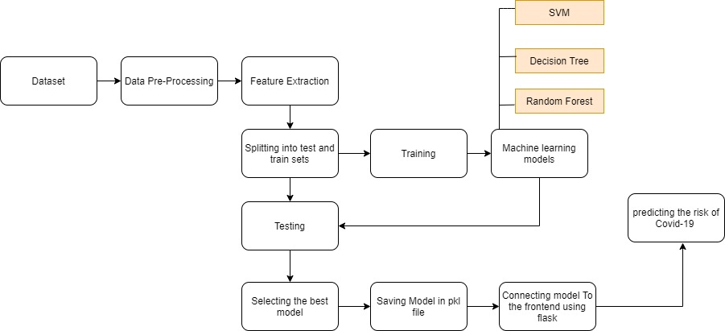

**Fig 3.1: System architecture**

### 3.3 UML

UML stands for Unified Modelling Language. UML is a standardized general-purpose modelling language in the field of object-oriented software engineering. The standard is managed, and was created by, the Object Management Group. The Unified Modeling Language (UML) is a general-purpose, developmental, modeling language in the field of software engineering that is intended to provide a standard way to visualize the design of a system. The goal is for UML to become a common language for creating models of object oriented computer software.

The UML represents a collection of best engineering practices that have proven successful in the modelling of large and complex systems. The UML is a very important part of developing objects oriented software and the software development process. The UML uses mostly graphical notations to express the design of software projects.

#### 3.3.1 Use Case Diagram

A use case diagram is a graphical depiction of a user's possible interactions with a system. A use case diagram shows various use cases and different types of users the system has and will often be accompanied by other types of diagrams as well. The use cases are represented by either circles or ellipses. The actors are often shown as stick figures.

While a use case itself might drill into a lot of detail about every possibility, a use-case diagram can help provide a higher-level view of the system. It has been said before that "Use case diagrams are the blueprints for your system". Use case diagrams are usually referred to as behaviour diagrams used to describe a set of actions that some system or systems should or can perform in collaboration with one or more external users of the system (actors). Each use case should provide some observable and valuable result to the actors.

In Figure 3.2 the use cases of the end users are depicted, the users are allowed to access the application. Then users are supposed to select the options they are provided with, then the application runs the trained machine learning model to predict the risk of covid-19 and gives the output to the users.

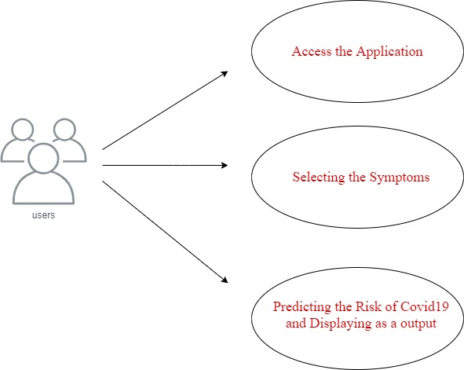

**Fig 3.2: Use case diagram for users**

#### 3.3.2 Sequence Diagram

A sequence diagram is a type of interaction diagram because it describes how—and in what order—a group of objects works together. These diagrams are used by software developers and business professionals to understand requirements for a new system or to document an existing process.A sequence diagram shows object interactions arranged in time sequence. It depicts the objects and classes involved in the scenario and sequence of messages exchanged between graphical manner. The objects needed to carry out the functionality of the scenario.

Sequence diagrams shows, as parallel vertical lines, different processor objects that live simultaneously, and, as horizontal arrows, the messages exchanged between them, in the order in which they occur. This allows the specification of simpler runtime scenarios in a graphical manner.

Figure 3.3 is the sequential diagram which shows how the processes are carried out by the application when a user interacts with it.

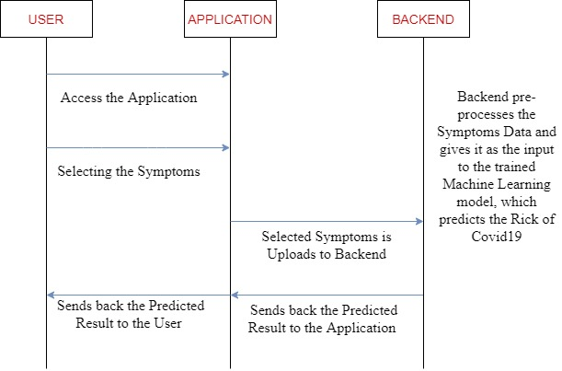

**Fig 3.3: Sequential diagram**

#### 3.3.3 Class diagram

A sequence diagram is a type of interaction diagram because it describes how—and in what order—a group of objects works together. These diagrams are used by software developers and business professionals to understand requirements for a new system or to document an existing process.

Class diagram is a static diagram. It represents the static view of an application. Class diagram is not only used for visualizing, describing, and documenting different aspects of a system but also for constructing executable code of the software application.

The class diagram for the application is as shown below:

* Server
* Application
* End user

*Server:*

The main functionality of the server is to get the parameters from the application, predict the result and send the result to the application.

*Application:*

The application accepts the parameters from the user and uploads it to the server. After the server predicts the result, the application gets the result from the server and shows it to the user with appropriate GUI

*End user:*

The user is supposed to choose the appropriate options on the application and view the results through the application.

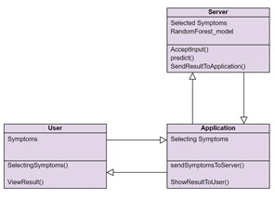

**Fig 3.4: Class diagram**

#### Activity diagram

Activity diagram is another important diagram in UML to describe the dynamic aspects of the system. Activity diagram is basically a flowchart to represent the flow from one activity to another activity. The activity can be described as an operation of the system. The control flow is drawn from one operation to another. This flow can be sequential, branched, or concurrent.

The purpose of activity diagrams is to captures the dynamic behavior of the system. Other four diagrams are used to show the message flow from one object to another but activity diagram is used to show message flow from one activity to another. Activity diagrams deal with all type of flow control by using different elements such as fork, join, etc. The activity can be described as an operation of the system. So the control flow is drawn from one operation to another. Activity diagrams are intended to model both computational and organizational processes.

The activity diagram in the Figure 3.5 depicts the flow of the operations as the user uses the application.

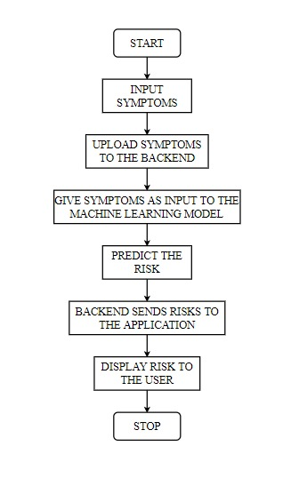

Figure 3.5 Activity diagram

### 3.4 Summary

In the design chapter the step by step explanation of the design is provided. The proposed designs that are explained in the design chapter by using UML diagrams, Class diagrams, Sequence diagrams and Activity diagrams which are considered to be efficient, and proved to be best suited.

## Implementation

Implementation is the stage of the project when the theoretical design is turned out into a working system. Thus the implementation part can be considered to be the most critical stage in achieving a successful new system and in giving the user, confidence that the new system will work and be effective.

The implementation stage involves careful planning, investigation of the existing system and it’s constraints on implementation, designing of methods to achieve changeover and evaluation of changeover methods.

### 4.1Importing the dataset and Encoding

import pandas as pd

import pickle

covid = pd.read_csv("data.csv")

from sklearn.preprocessing import LabelEncoder

e=LabelEncoder()

covid['Breathing Problem']=e.fit_transform(covid['Breathing Problem'])

covid['Fever']=e.fit_transform(covid['Fever'])

covid['Dry Cough']=e.fit_transform(covid['Dry Cough'])

covid['Sore throat']=e.fit_transform(covid['Sore throat'])

covid['Running Nose']=e.fit_transform(covid['Running Nose'])

covid['Asthma']=e.fit_transform(covid['Asthma'])

covid['Chronic Lung Disease']=e.fit_transform(covid['Chronic Lung Disease'])

covid['Headache']=e.fit_transform(covid['Headache'])

covid['Heart Disease']=e.fit_transform(covid['Heart Disease'])

covid['Diabetes']=e.fit_transform(covid['Diabetes'])

covid['Hyper Tension']=e.fit_transform(covid['Hyper Tension'])

covid['Abroad travel']=e.fit_transform(covid['Abroad travel'])

covid['Contact with COVID Patient']=e.fit_transform(covid['Contact with COVID Patient'])

covid['Attended Large Gathering']=e.fit_transform(covid['Attended Large Gathering'])

covid['Visited Public Exposed Places']=e.fit_transform(covid['Visited Public Exposed Places'])

covid['Family working in Public Exposed Places']=e.fit_transform(covid['Family working in Public Exposed Places'])

covid['Wearing Masks']=e.fit_transform(covid['Wearing Masks'])

covid['Sanitization from Market']=e.fit_transform(covid['Sanitization from Market'])

covid['COVID-19']=e.fit_transform(covid['COVID-19'])

covid['Dry Cough']=e.fit_transform(covid['Dry Cough'])

covid['Sore throat']=e.fit_transform(covid['Sore throat'])

covid['Gastrointestinal ']=e.fit_transform(covid['Gastrointestinal '])

covid['Fatigue ']=e.fit_transform(covid['Fatigue '])

### 4.2 Training and Testing the model using various algorithms

from sklearn.linear_model import LogisticRegression

model = LogisticRegression()

model.fit(x_train, y_train)

y_pred = model.predict(x_test)

acc_logreg=model.score(x_test, y_test)*100

print("logisticRegression is=",acc_logreg)

print(confusion_matrix(y_test, y_pred))

from sklearn.ensemble import RandomForestClassifier

rf = RandomForestClassifier(n_estimators=500)

rf.fit(x_train, y_train)

y_pred = rf.predict(x_test)

acc_randomforest=rf.score(x_test, y_test)*100

print("RandomForestClassifier is =",acc_randomforest)

print(confusion_matrix(y_test, y_pred))

from sklearn.ensemble import GradientBoostingClassifier

GBR = GradientBoostingClassifier(n_estimators=100, max_depth=4)

GBR.fit(x_train, y_train)

y_pred = GBR.predict(x_test)

acc_gbk=GBR.score(x_test, y_test)*100

print("GradientBoostingClassifier is =",acc_gbk)

print(confusion_matrix(y_test, y_pred))

from sklearn.neighbors import KNeighborsClassifier

knn = KNeighborsClassifier(n_neighbors=20)

knn.fit(x_train, y_train)

y_pred = knn.predict(x_test)

acc_knn=knn.score(x_test, y_test)*100

print("KNeighborsClassifier is =",acc_knn)

print(confusion_matrix(y_test, y_pred))

from sklearn.tree import DecisionTreeClassifier

t = DecisionTreeClassifier()

t.fit(x_train,y_train)

y_pred = t.predict(x_test)

acc_decisiontree=t.score(x_test, y_test)*100

print("Decisiontree is =",acc_decisiontree)

print(confusion_matrix(y_test, y_pred))

from sklearn.naive_bayes import GaussianNB

model = GaussianNB()

model.fit(x_train,y_train)

y_pred = model.predict(x_test)

acc_gaussian= model.score(x_test, y_test)*100

print("GaussianNB is =",acc_gaussian)

print(confusion_matrix(y_test, y_pred))

from sklearn import svm

clf = svm.SVC(kernel='linear')

clf.fit(x_train, y_train)

y_pred = clf.predict(x_test)

acc_svc=clf.score(x_test, y_test)*100

print("SVM is =",acc_svc)

print(confusion_matrix(y_test, y_pred))

### 4.3 Connecting the model to the Front End

import numpy as np

from flask import Flask, request, jsonify, render_template

import pickle

app = Flask(__name__)

model = pickle.load(open('model.pkl', 'rb'))

@app.route('/')

def home():

return render_template('homepage.html')

@app.route('/precautions')

def precautions():

return render_template('precautions.html')

@app.route('/index')

def index():

return render_template('index.html')

@app.route('/symptoms')

def symptoms():

return render_template('Symptoms.html')

@app.route('/treatments')

def treatments():

return render_template('treatments.html')

@app.route('/predict',methods=['POST'])

def predict():

int_features = [int(x) for x in request.form.values()]

final_features = [np.array(int_features)]

prediction = model.predict(final_features)

output = round(prediction[0], 2)

if output == 1:

msg=" High "

else :

msg=" Low "

return render_template('result.html', prediction_text='The Risk Of Covid-19 for you is {} '.format(msg))

if __name__ == "__main__":

app.run(debug=True)

# 

## Testing

The purpose of testing is to discover errors. Testing is the process of trying to discover every conceivable fault or weakness in a work product. It provides a way to check the functionality of components, sub-assemblies, assemblies and/or a finished product. It is the process of exercising software with the intent of ensuring that the software system meets its requirements and user expectations and does not fail in an unacceptable manner. There are various types of test. Each test type addresses a specific testing requirement.

### Introduction of Testing

Testing is a development procedure where programmers create tests as they develop software. The tests are simple short tests that test functionality of a particular unit or module of their code, such as a class or function. Software testing is any activity aimed at evaluating an attribute or capability of a program or system and determining that it meets its required results. Testing is more than just debugging. The purpose of testing can be quality assurance, verification or reliability estimation. Testing can be used as a generic metric as well.

### 5.2 Software Testing.

Software testing is the process of verifying a system with the purpose of identifying any errors, gaps or missing requirement versus the actual requirement. Testing should be started as early as possible to reduce the cost and time to rework and produce software that is bug-free so that it can be delivered to the client. However, in Software Development Life Cycle (SDLC), testing can be started from the Requirements Gathering phase and continued till the software is out there in productions.

#### 5.2.1 Unit Testing

Unit testing is a type of software testing where individual units or components of a software are tested. The purpose is to validate that each unit of the software code performs as expected. Unit Testing is done during the development (coding phase) of an application by the developers. Unit Tests isolate a section of code and verify its correctness. A unit may be an individual function, method, procedure, module, or object.

Table 5‑1: Test cases for the project

|  |  |  |
| --- | --- | --- |
| **Steps** | **Test Action** | **Results** |
| Step 1 | Enter the URL:  http://127.0.0.1:5000/ | Home page loaded. |
| Step 2 | Click on predict covid-19 risk | Risk prediction page loaded. |
| Step 3 | Fill the details | Data analysed. |
| Step 4 | Click on the predict button | Risk predicted. |
| Step 5 | Press back button | Home page loaded |

Importance of unit testing:

* Unit Testing is important because software developers sometimes try saving time doing minimal unit testing and this is myth because inappropriate unit testing leads to high cost Defect fixing during System Testing,
* Integration Testing and even Beta Testing after application is built.
* If proper unit testing is done in early development, then it saves time and money in the end.
* Unit tests help to fix bugs early in the development cycle and save costs.
* It helps the developers to understand the testing code base and enables them to make changes quickly.
* Good unit tests serve as project documentation.
* Unit tests help with code re-use. Migrate both your code and your tests to your new project. Tweak the code until the tests run again.

Test objectives:

* All field entries must work properly.
* Pages must be activated from the identified link.
* The entry screen, messages and responses must not be delayed.

#### 5.2.2 User Acceptance Testing

User Acceptance Testing (UAT) is a type of testing performed by the end user or the client to verify/accept the software system before moving the software application to the production environment. UAT is done in the final phase of testing after functional, integration and system testing is done.

The main Purpose of UAT is to validate end to end business flow. It does not focus on cosmetic errors, spelling mistakes or system testing. User Acceptance Testing is carried out in a separate testing environment with production-like data setup. It is kind of black box testing where two or more end-users will be involved.

**Test Results:** All the test cases mentioned were successfully. No defects encountered.

#### Output Testing

After performing the validation testing, the next step is output testing of the proposed system, since no system could be useful if it does not produce the required output in the specified format. Asking the users about the format required by them tests the outputs generated or displayed by the system under consideration. Hence the output format is considered in two ways, one is on screen and another in printed format.

#### Validation Checking

Validation is an automatic computer check to ensure that the data entered is sensible and reasonable. It does not check the accuracy of data.

Validation testing is centred on the following items:

Valid Input : identified classes of valid input must be accepted.

Invalid Input: identified classes of invalid input must be rejected.

Functions : identified functions must be exercised.

Output : identified classes of application outputs must be exercised.

Procedures : interfacing systems or procedures must be invoked.

### 5.3 System Testing

System testing occurs when a complete and integrated software is tested. The purpose of this test is to evaluate the compliance of the system within the specified requirements. It also helps with approving and checking business requirements. These include functional, technical, and any non-functional requirements of the application that deal with the architecture as a whole.

Table 5‑2: Test cases for Input-Output

|  |  |
| --- | --- |
| **Name of the Test** | **System Testing** |
| Item being tested | Over all functioning of the system with all functions properly linked. |
| Sample Input | A patient health details must be uploaded. |
| Expected Output | Application should display level of covid-19 risk. i.e, either high or low. |
| Actual Output | Application reacts to user inputs in expected manner and displays the level of risk. |
| Remarks | Successful |

# 

## Results and Discussions

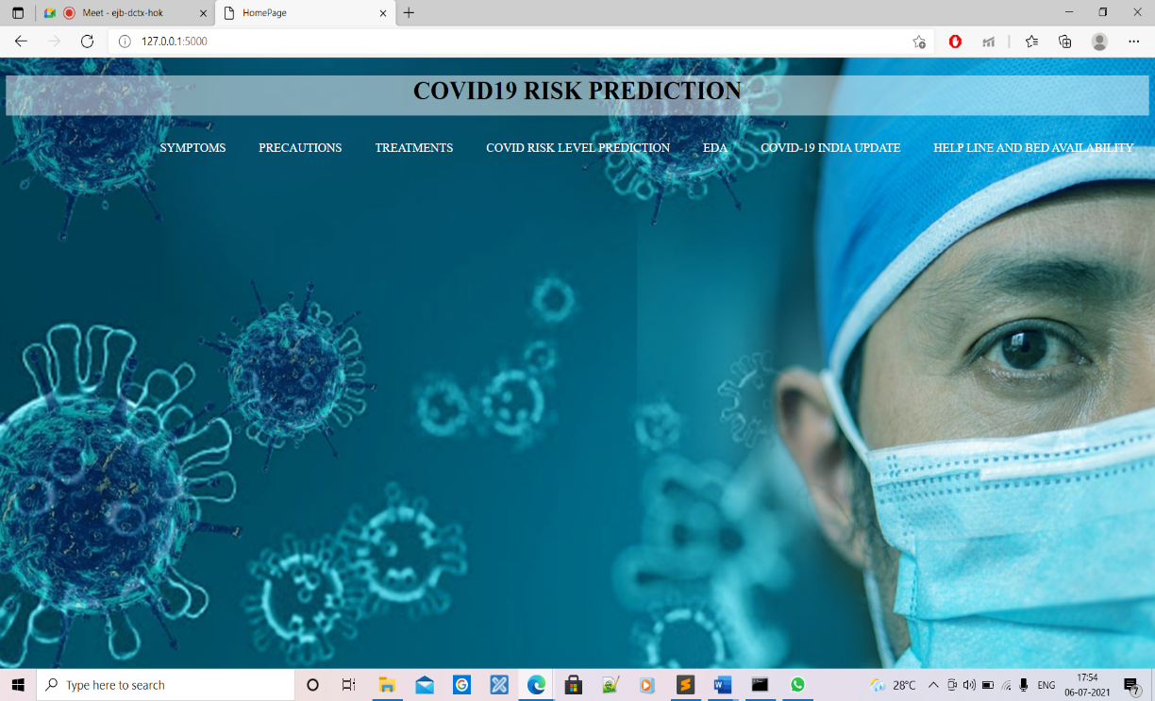

Figure 6.1 Home page

The figure 6.1, shows the Home Page after an applicant opens the site

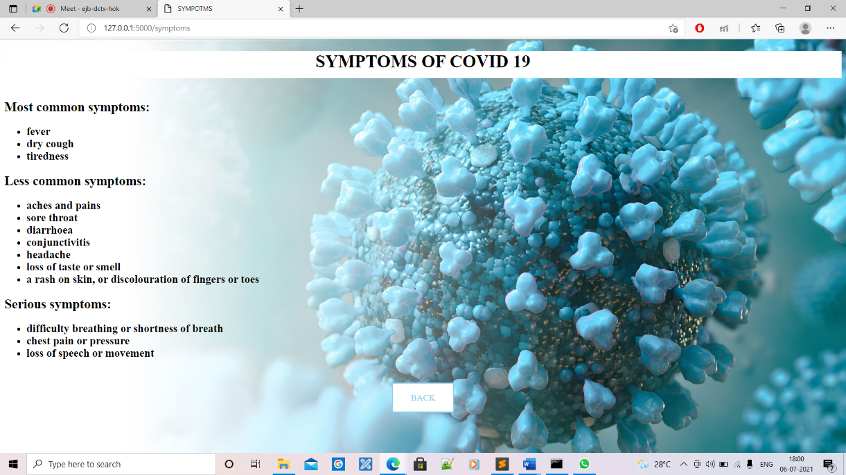

Figure 6.2 Symptoms

The Figure 6.2, shows the login page for the cloud server, which requests for the credentials needed. Once the credentials are accepted it logs in to the cloud server.

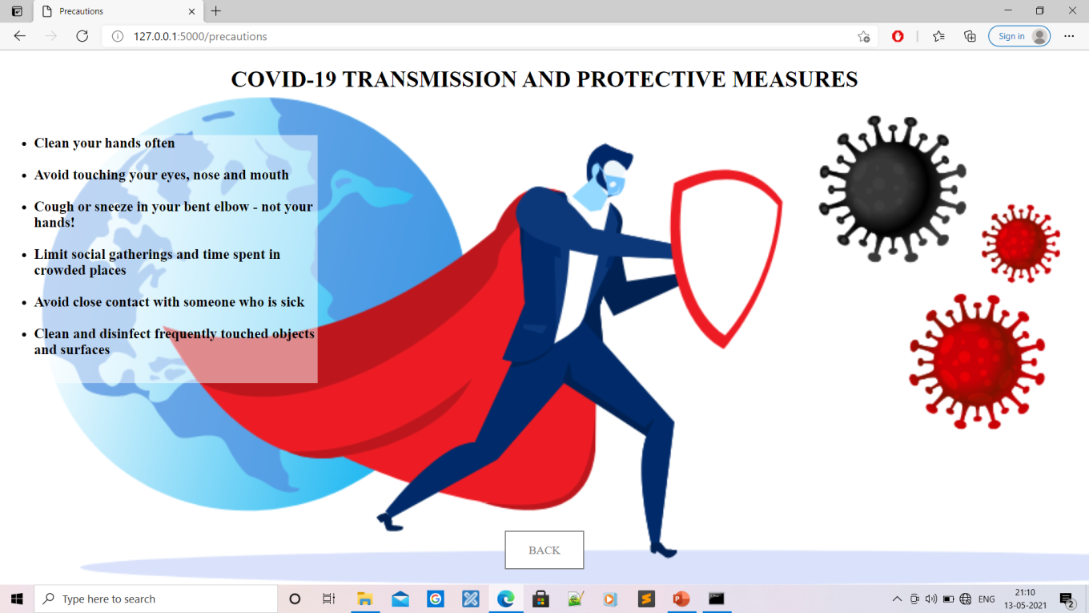

Figure 6.3 Precautions

The Figure 6.3, shows the registration form of the Service provider, where registration happens in order to perform various functionalities. Which has to be approved by the cloud.

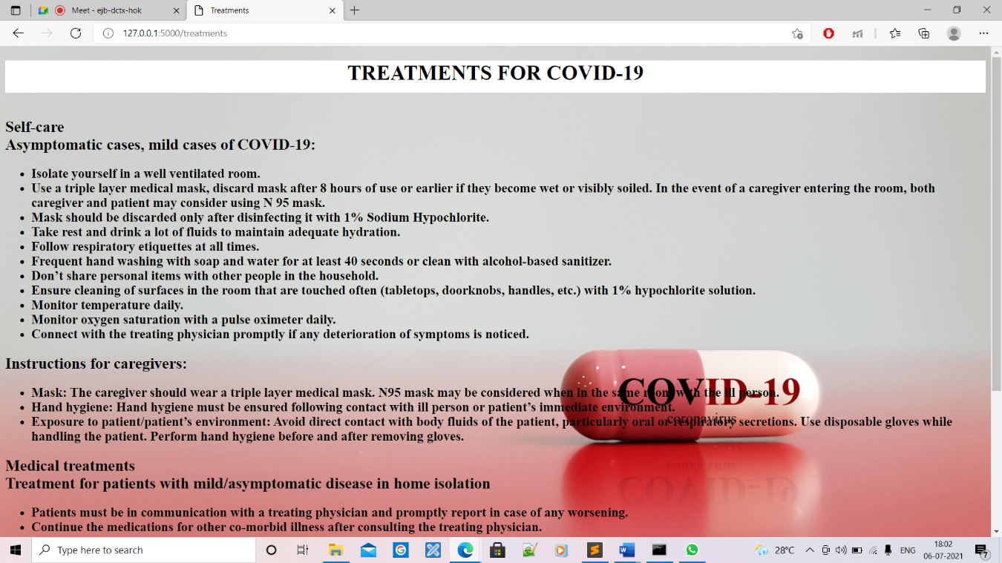

Figure 6.4 Treatments

The Figure 6.4, shows the page in the cloud server which can check the details of the registered service provider or end-user that must be authorized and does the authentication work. The cloud server has to click on the un-authorize button which will then authorize the registered person and the above result will be obtained.

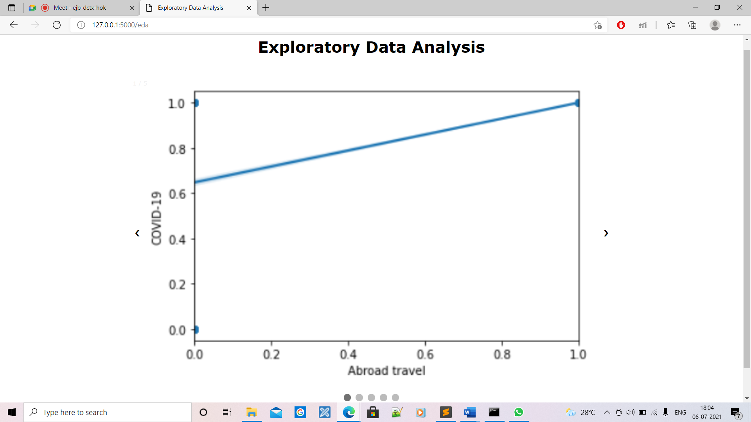

**Figure 6.5 Exploratory Data Analysis**

The Figure 6.5 Shows the Graph of Covid19 vs Abroad Travel

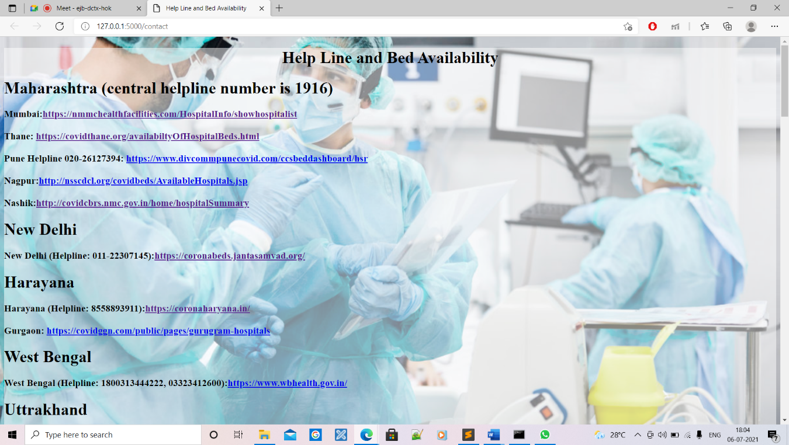

**Figure 6.6 Help Line and Bed Availability**

The Figure 6.6 Shows the contact details of covid related information and bed availability with respect to specific region .



Figure 6.7 Covid-19 Risk Level Prediction

The Figure 6.7 is the screenshot of the file being uploaded by the service provider, which can later be downloaded by end-users.

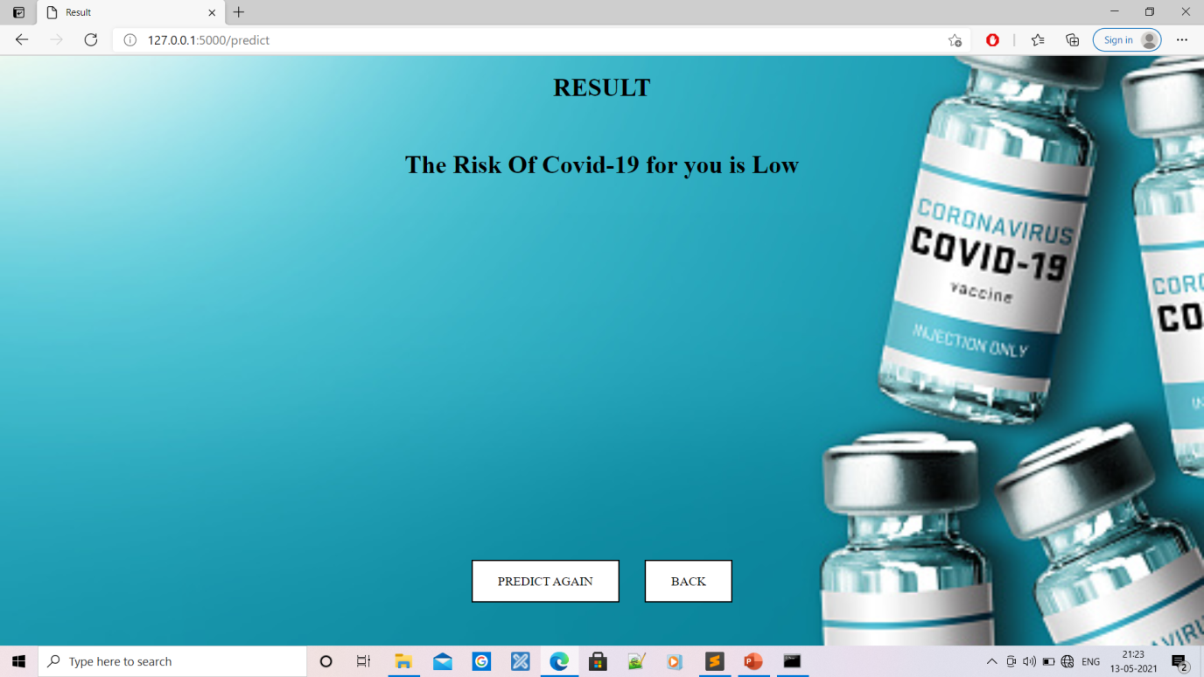

Figure 6.8 Result

The Figure 6.8 is the screenshot where the cloud server can view all the requests made by the service provider while uploading the file. The cloud server can respond to the request or he can keep the file request waiting.

# 

## Conclusion and Future Work

### 7.1 Conclusion

Through our analysis, it’s been proven that our project predicts the individual’s covid-19 risk. Data preprocessing is successfully done on the dataset. Machine learning algorithms such as Logistic Regression, Random Forest, Support Vector Machine, Decision Tree , K Neighbors and Gradient Boosting, Gaussian NB are used in the model. Experimental results shows that random forest technique achieve highest classification accuracy of 98% comparatively with other techniques**.** The analysis and risks of COVID-19 is predicted through predictive model and presented through a web interface using flask and html.

### 7.2Future Work

Although, we consider that the goal of the project has been accomplished, there are plenty of improvements that could be done in order to achieve better results. Some aspects like HTML and CSS can be further improved and changing the static page into dynamic page. Further, by implementing more better dataset the results could become more accurate and precise.

## References

1. Ahmad S, Hafeez A, Siddqui SA, Ahmad M, Mishra S. A Review of COVID-19 (Coronavirus Disease-2019) Diagnosis, Treatments and Prevention. EJMO 2020;4(2):116–125.
2. Hao Y, Xu T, Hu H, Wang P, Bai Y (2020) Prediction and analysis of Corona Virus Disease 2019. PLoS ONE 15(10): e0239960. https://doi. org/10.1371/journal.pone.0239960.
3. Harmon, S.A., Sanford, T.H., Xu, S. et al. Artificial intelligence for the detection of COVID-19 pneumonia on chest CT using multinational datasets. Nat Commun 11, 4080 (2020).<https://doi.org/10.1038/s41467-020-17971-2>.
4. Binti Hamzah FA, Lau C, Nazri H, Ligot DV, Lee G, Tan CL, et al. CoronaTracker: WorldwideCOVID-19 Outbreak Data Analysis and Prediction. [Preprint]. Bull World Health Organ.E-pub: 19 March 2020. doi: http://dx.doi.org/10.2471/BLT.20.255695.